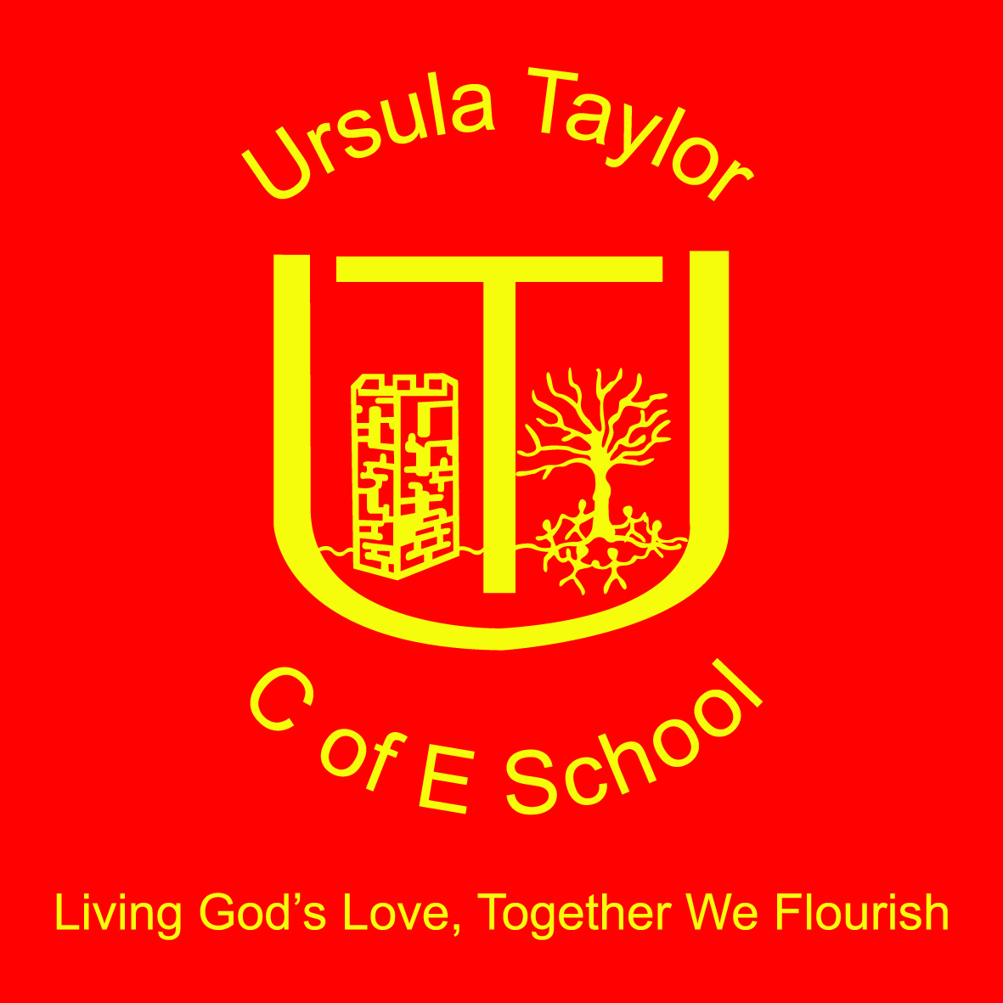
Ursula Taylor Church of England School
High Street, Clapham,
Bedford, MK41 6EG
01234 359128 / 326251
office@ursulataylor.bedssch.co.uk
Headteacher: Mrs Victoria Morrall

Party in the Park

9th June 2016
Dear Parents/Carers,
The choir have been invited to join the Clapham Community Gospel Choir in singing some familiar songs at ‘Party in the Park’. The event is to take place on Sunday, 19th June, at Clapham King George Playing field. It will be a family day filled with fun activities and a free barbecue for the whole family. The event will be from 2 – 4.30 pm with the choir singing at some point between 3 – 4.30 pm, as part of the ‘Praise in the Field’

Although I will be at the event, unfortunately, I am unable to take responsibility for the children. Therefore, I ask that you stay for the duration to care for your child.

Many thanks for your continued support.

Yours sincerely,

S Wintle

