URSULA TAYLOR C of E PRIMARY SCHOOL
Headteacher: Mrs V. J. Morrall

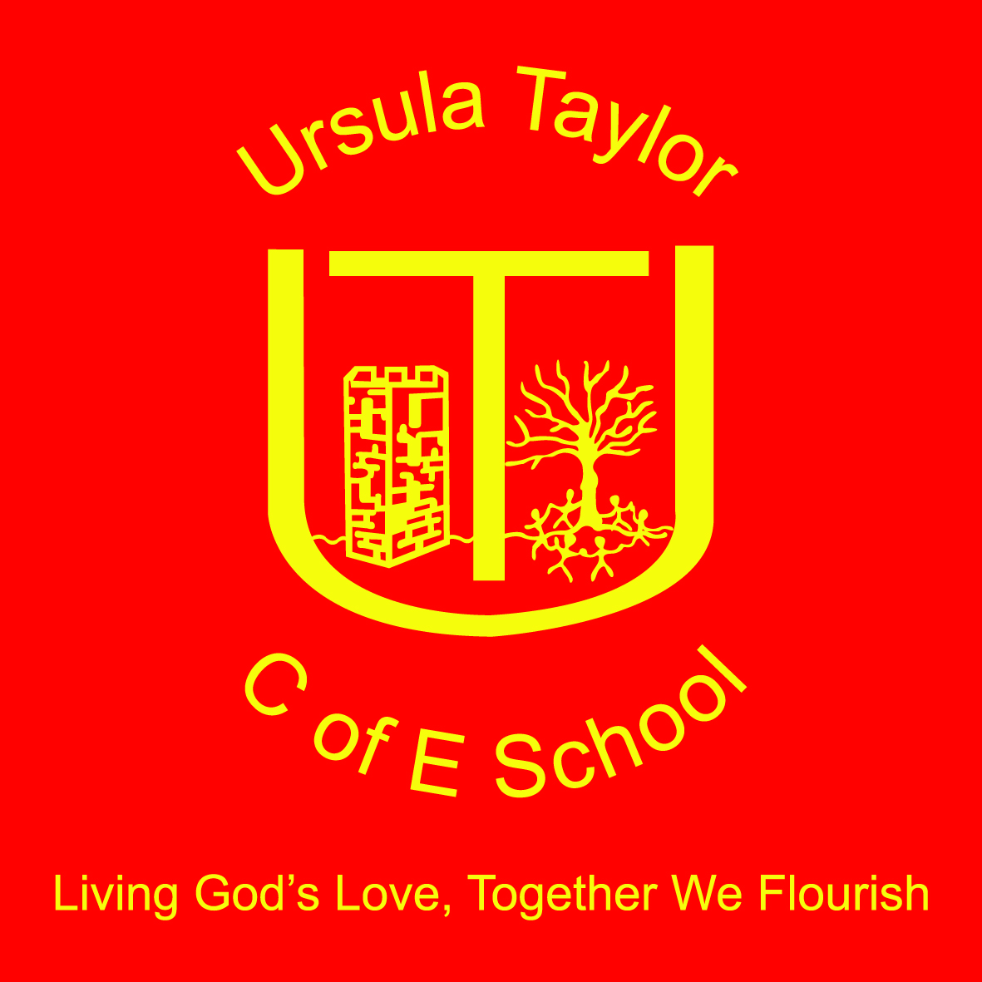

High Street, Clapham, Bedfordshire, MK41 6EG Tel: 01234 359128/326251
e-mail: office@ursulataylor.bedssch.co.uk

May 2017

Dear applicant,

Thank you for your interest in the post of Class Teacher at Ursula Taylor Church of England School. This is a permanent post and is open to all teacher with experience in a Primary School. The role in the first year is in Foundation Stage, however this may not continue to be the case from September 2018.

Applicants who are MPS / UPS are welcome to apply, for experienced applicants , there is the opportunity to manage an area of our curriculum. This has not yet been determined and will be open to negotiation.

Our Foundation Stage Team is very experienced and offers our children a rich curriculum and a wide range of valuable experiences. The Teaching in our Foundation Stage is of high quality and we are looking to appoint a teacher who can engage and excite our children, meet our expectations and support us on our journey towards becoming an outstanding school.

Please find enclosed/attached an application form, Job Description and Personnel Specification. I would recommend you visit our website http://www.ursulataylorschool.co.uk for further information about our school. We welcome visits to school, should you wish to visit, please contact Miss. Debbie Daley in the school office to arrange an appointment. We are flexible with dates and encourage visits during the day to see our school in action.

We are fully committed to Safeguarding and fulfil all our responsibilities relating to Safer Recruitment. References will be followed up and a full DBS Clearance and Disqualifications Declaration will be required.

Once again I would like to thank you for your interest in this post.

Yours Sincerely,
Victoria Morrall

VJ Morrall

Headteacher
Ursula Taylor C of E School

