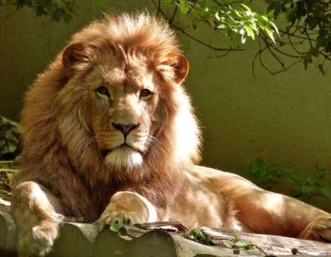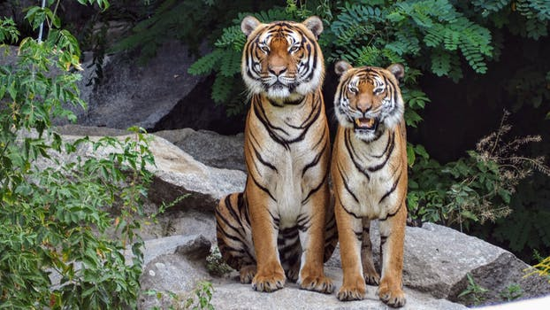

**Into the Wild!**

Class Information

Simmonds Class

PE

Children need their PE kits in school all week. Our lessons will be on Wednesday & Thursday. **Children will need socks and trainers for outdoor P.E.**

Wellies

Children need to have a pair of wellies in school every day stored under their coat peg.

Library

Children will be able to change their school library book on a Monday.

Radcliffe Class

PE

Children need their PE kits in school all week. Our lessons will be on Tuesday & Thursday. **Children will need socks and trainers for outdoor P.E.**

Wellies

Children need to have a pair of wellies in school every day stored under their coat peg.

Library

Children will be able to change their school library book on a Monday.

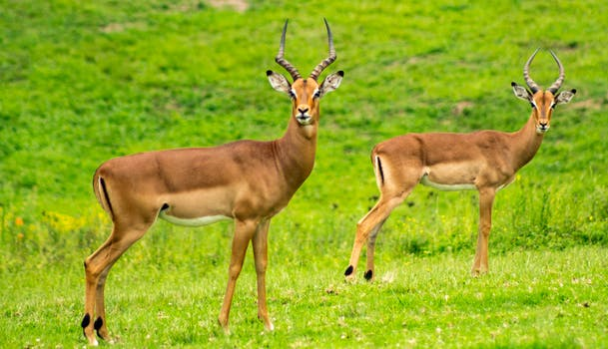

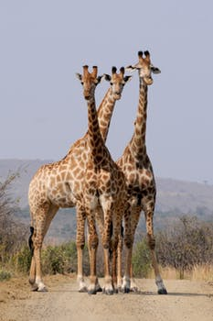

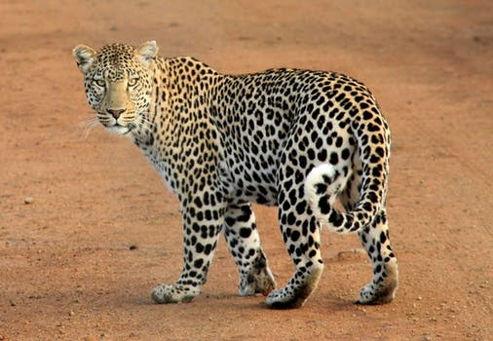

This term our topic will be ‘Into the Wild!’. We will be exploring wild animals, their habitat and reading a range of stories including ‘Tinga Tinga Tales’ and ‘Giraffe’s can’t dance!’

Ursula Taylor C of E Primary School

Year 1

Our big question this term is **‘What makes something wild?’**

Reminders

Please make sure your child has a water bottle provided each day.

Please can you read with your child a home, at least 3 times a week and sign their reading record book. Thank you.

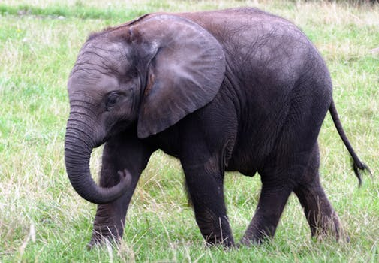

**English**

Our English work will include writing character profiles, retelling stories and writing information books.

**Maths**

Our focus will be solving problems involving counting, adding and subtracting. Children will continue to recall number bonds to 10 and begin to learn number bonds to 20. Visualising, naming and describing 2D and 3D shapes will also be included in practical maths.

**Key Texts**

‘Giraffe’s can’t Dance!’ by Giles Andreae

‘Why Elephant has a Trunk’ Tinga Tinga Tales

‘Wanted the perfect pet’ by Fiona Roberton

**P.E.**

Multi skills will be taught all term. Gymnastics will be taught after half term.

**Topic (Geography/History/Science/Art)**

Under our umbrella topic of ‘Into the Wild’ we will be exploring where animals live on our planet, the continent and their habitat.

We will be looking at a range of different animals, identifying and naming them as well as learning about carnivores, herbivores and omnivores. We will be looking at the Tinga Tinga tale art work and creating some masterpieces of our own!

**Challenge Books**

For the first term we will be continuing with our home challenge books. A new challenge will be stuck in on a Friday and will need to return to school a week on the Wednesday. Please see your class teacher for any guidance and a gentle reminder that the challenges are for the children to complete with your support.

**R.E.**

Children will be learning about harvest and what it means to belong. We will also be learning about the Christian story of Creation.

**Computing**

The children will continue to use a variety of software and programmable robots in their topic work. We will be using Google Earth in our topic.

**Mini Topics:**

Guy Fawkes

Diwali

Christmas

**Useful websites**

https://www.bbc.co.uk/cbeebies/topics/animals

https://www.phonicsplay.co.uk/freeIndex.htm

**Gardening/Cooking**

We would like to continue to grow vegetables in our garden and give the children opportunities for cooking. Therefore we ask for your support and a voluntary donation of £5 per term to enable us to facilitate this. We thank you in advance.