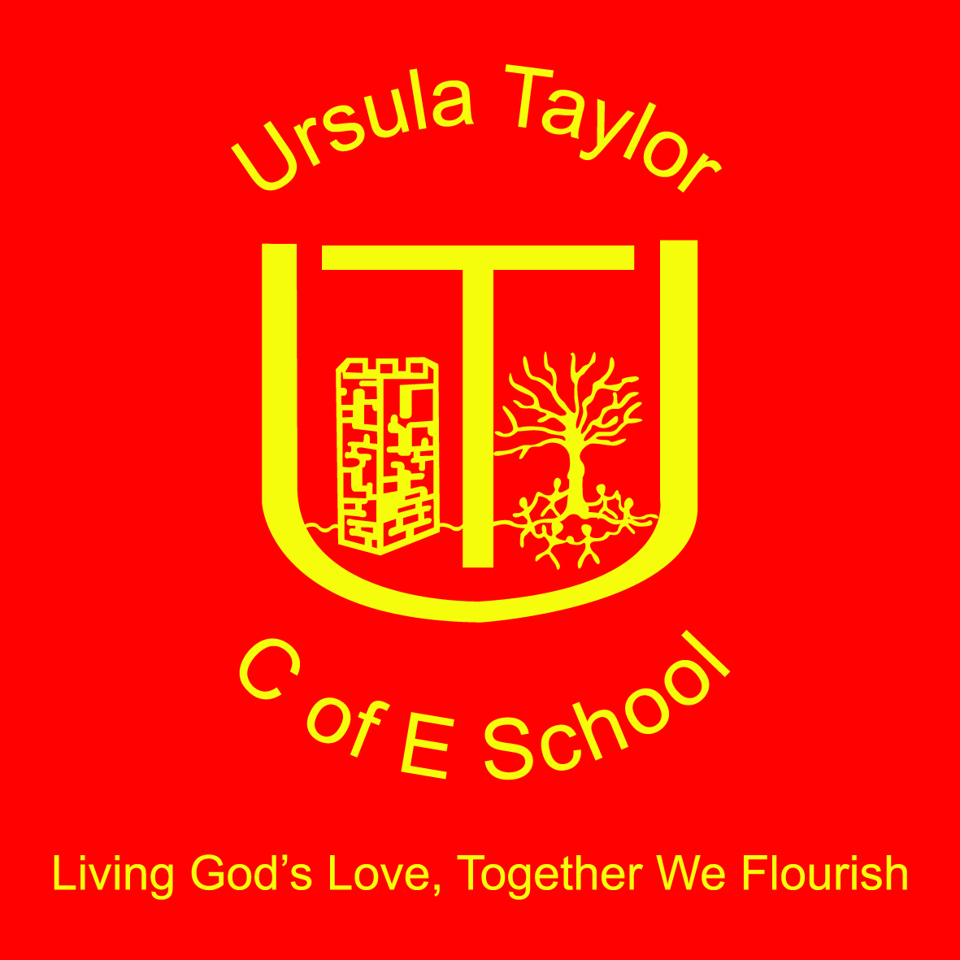
Ursula Taylor Church of England School
High Street, Clapham,
Bedford, MK41 6EG
01234 359128 / 326251
office@ursulataylor.bedssch.co.uk
Headteacher: Mrs Victoria Morrall

Bees Sport Festival
10th June 2016
Dear Parents/Carers,

Bees Class will be taking part in a Sports Festival on the morning of Tuesday, 21st June 2016 at Margaret Beaufort Middle School. The children will be participating and competing with KS1 teams from many local schools. They will take part in Athletics, Tri-golf and Rounders. The children will need to ensure they have suitable clothing for outdoor sports but must wear their school sweatshirt. They may come into school in their sports kit and will remain in this for the rest of the day. Please ensure they have a waterproof coat with them in case of bad weather and their water bottle.
The children will be back in school in time for their usual school lunch.
There is no cost for this event, although we will need your permission for your child to travel by coach. Please complete and return the permission slip below prior to Friday 17th June.

Yours sincerely,

S. Wintle
PE Co-ordinator

Bees Sports Festival

I give permission for my child ………………………………………………………….. to travel by coach and attend the Sports Festival Competition on Tuesday 21st June

Signed ………………………………………………………….. Date ……………………………

