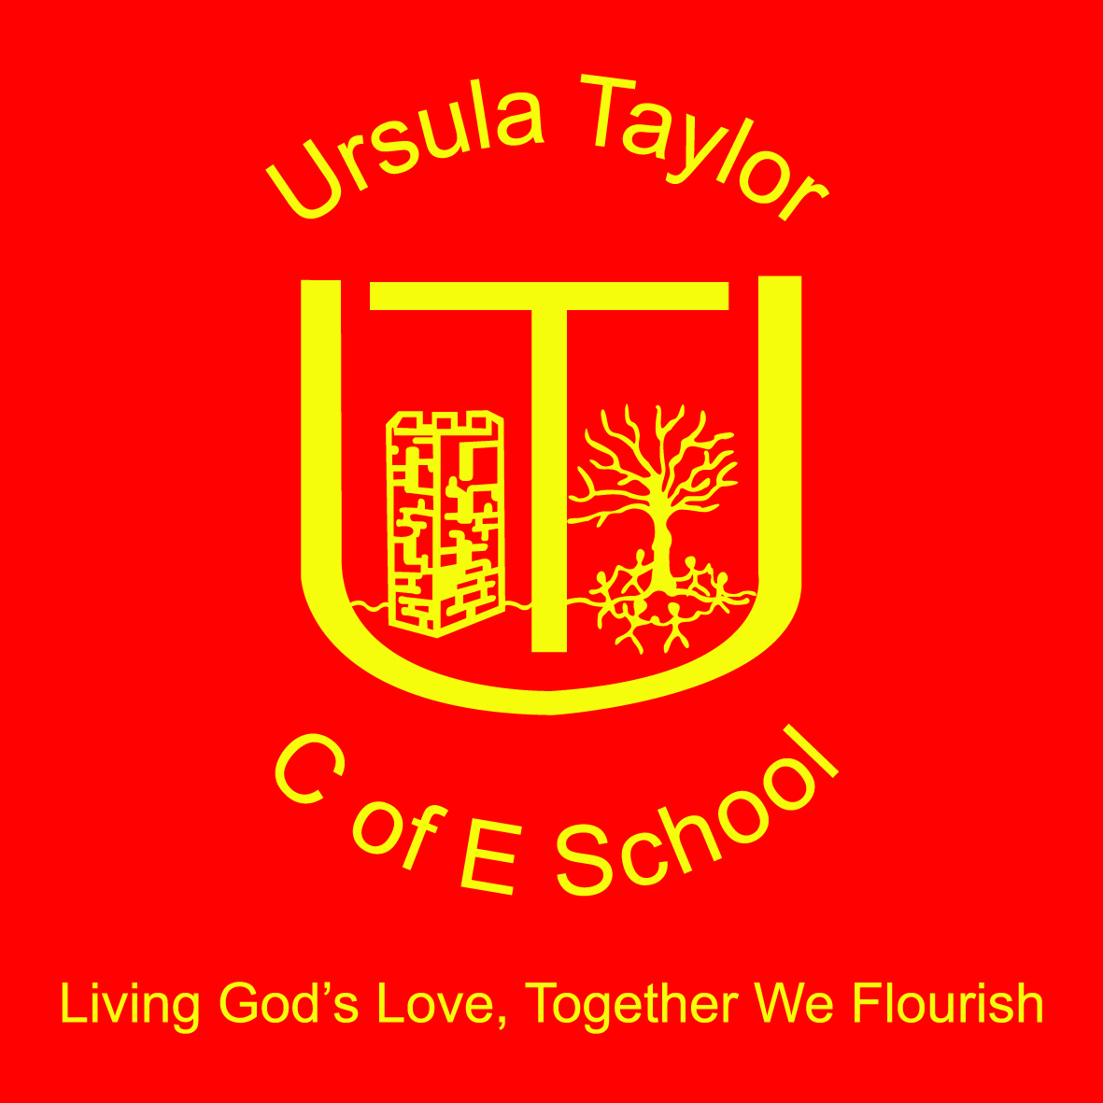

Ursula Taylor Church of England Primary School
Collective Worship Policy
Introduction
Collective worship is central to the life of the school. Worship offers the children and others in the school an opportunity to reflect on values and issues in the context of our Christian Ethos. It reflects the mission statement and shapes our approach to others and to what we do in school. At Ursula Taylor we believe that ‘Living God’s Love, Together we Flourish’ and that whole school Christian led worship is an important way to aspire to this.
Our Collective Worship provides the children, staff and parents the opportunity to:
- Worship God
- Experience a variety of styles of worship
- Celebrate:
  - Christian festivals
  - School Values
  - Achievements
- Grow in understanding of and participation in prayer.
- Develop a reflective approach to life and reflect on Christian Values
- Develop as a community, based on Christian Values
- Participate and respond, through active involvement in the planning, leading, presentation and evaluation of worship
- Feel safe and affirmed
At times worship will reflect aspects of the curriculum and in particular will:
- Nurture spiritual growth
- Consider Moral issues in a Christian context
- Enhance social understanding
- Explore beliefs drawn from their own cultural heritage
More information about Spiritual, Moral, Social and Cultural Development can be found in our SMSC Policy.
The Pattern of Collective Worship
Collective worship takes place in a variety of ways, in the school hall, in classrooms, outside and also in our local Church, St Thomas a Beckett. We follow the seasons of the church year and within this significant festivals and other special days are observed. These always include Harvest, Christmas, Ash Wednesday, Easter and Pentecost. Other days such as Candlemas and Trinity Sunday are celebrated occasionally.
The pattern of worship at UTS is as follows:
Day of the week | Led by | Attendees
Monday | Headteacher / Open the Book | All Children and Staff
Tuesday | Headteacher | All Children
Wednesday | Rev. Stephen Liley | All Children and Staff
Thursday | Hymn Practice – Miss S Wintle | All Children
Friday | Golden Assembly / Awards Assembly – Headteacher / Deputy Headteacher / Assistant Headteacher | Whole school, staff and invited parents

We also have a Class led Values Assembly at the start and end of every half term, where the children plan a worship for the whole school to teach them about the new Value for the team. This worship is always grounded in Christian teachings and features a song and prayer linked to the new value and also Christian beliefs.
Leading Worship
The overall school Collective worship leader is the Headteacher – Mrs Victoria Morrall, who is supported by our Local Church Reverend Stephen Liley, Our Church Group ‘Open the Book’ and also the staff and children of our school. Visitors are welcome to lead Collective worship from time to time and are given guidance on our Worship Policy. Leaders from faiths within the area help us to increase the pupil’s awareness, promote respect and raise self-esteem of the pupils who belong to these faiths.
Planning acts of worship
Our acts of worship are carefully planned to ensure a balance between content and experience. Leaders, including the children, Rev. Stephen Liley and staff, plan the content and activities included in worship according to what is most appropriate to the theme or season, and the ages, aptitudes and background of the children. Throughout their time at our school, children will encounter a wide variety of activities such as dance and drama alongside traditional elements such as prayer and song. See Appendix 1 for a list of resources and website used for planning Collective Worship.
Prayer is a vital part of our worship. It is introduced with a form of words that invites but does not coerce children, staff and parents to participate. Our prayers are addressed to Jesus and God reflecting the traditions and practices of the Church of England. Children, staff and parents who prefer not to pray are encouraged to use these times to reflect on important messages shared in our worship.
Our worship is reviewed and monitored regularly and Christian Distinctiveness, including Collective worship is specifically detailed on our School Development Plan and also reviewed by our Governing Body. Our School Improvement Partner – Mrs Judy Ruff, is also a Diocese of St. Albans Consultant and experienced Church School Inspector (SIAMs)
Legal Note relating to Collective Worship:
By law, Collective worship must:
- Be provided for every child, every day
- Reflect the schools Trust Deed
Our Policy sets out clearly our aspiration that Collective Worship will be valuable and a valued experience for all members of our school community, whatever their backgrounds or beliefs. It is inspirational, inclusive and reflective in nature and never coercive or indoctrinatory.
Parents have a right to withdraw their children from all or any acts of worship. In the first instance we ask parents who may wish to exercise this right to visit school to speak to the Headteacher.
Policy updated and Ratified 10th November 2016
Renewal Date November 2017

APPENDIX 1
Collective Worship Resources:
- Diocese of St Albans, Units of work on Christianity
- RE Today – Understanding Christianity Curriculum
- Experience Christmas / Experience Easter / Experience Harvest – Jumping Fish (Diocese of Gloucester)
- Values for Life. Jumping Fish (Diocese of Gloucester)
- Primary Assembly Files PfP
- All Year Round Assemblies PfP
- Values Education – Neil Hawkes
- Out of the Box KS1 – Imaginor
- Roots and Fruits, Creative Collective Worship for Primary Schools linked to Christian Values. Imaginor
- Diocese of Leicester – Themes and Resources for Collective Worship
Websites:
- www.assemblies.org.uk
- www.barnabasinschools.org.uk
- http://ministery-to-children.com
- www.biblebasedassemblies.com
- www.paperlesschristmas.org.uk

