**Useful information for this term:**

* Please can we remind you that your child should have their reading book and learning log in school daily and that they should be reading at home as often as possible.
* Each week your child will have a set of spellings sent home for them to practise. These will be tested each Monday morning. They will also have a piece of maths homework sent home on Fridays that will be marked the following Friday morning.
* We encourage the children to extend their learning at home. Work related to our topic will be displayed in the classroom. In Year 2, ‘show and tell’ should relate to our topic or recent achievements.
* We hope that your child enjoys this term in Year Two but if you have any concerns please don’t hesitate to come and speak to us.

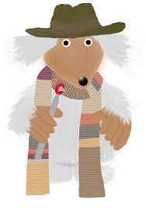

Overground, Underground, Explorers are we……

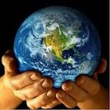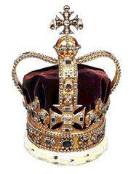

**Useful Websites**

English/Maths: [www.topmarks.co.uk](http://www.topmarks.co.uk)

[www.funenglishgames.com](http://www.funenglishgames.com)

Topic: [www.bbc.co.uk/history/british](http://www.bbc.co.uk/history/british)

In RE we are looking at the Earth and why we should take care of it. We will look at the Bible to discover more about our world and how Christians believe it was created.

In PE our outdoor focus during Autumn 1 will be football and in Autumn 2, hockey. Our indoor focus will be gymnastics. In addition to this, we will also continue to run a mile each week.

We are very excited about our topic which will run throughout this year. Each term we will have a different theme, ‘To Build’, ‘To Grow’ and ‘To Discover’.

Our focus for this Autumn term is ‘To Build’ and we will be looking at castles and British Monarchs.

In ICT we will be learning how to research using the internet to search for information linked to our topic. We will also learn more about Microsoft word and develop our understanding of the tools linked to this programme.

In History we will help the children to develop an awareness of the past and how things have changed alongside looking at the lives of British Monarchs and significant individuals and events that have shaped history.

In Literacy we will looking at traditional fairy tales and our non- fiction work will be based around castles and British History.

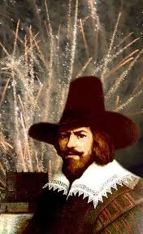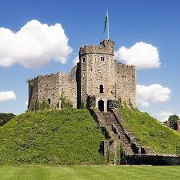

**To Build………**

[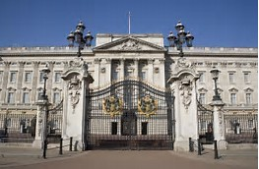](http://www.bing.com/images/search?view=detailV2&ccid=B4ZkK+UK&id=D1B1E9EF9A39B29C2EEE2C2DF932D46405D1CD4D&thid=OIP.B4ZkK-UKhHYNAUVr5Kg6gAEyDM&q=buckingham+palace&simid=608001456250621866&selectedIndex=12&adlt=strict&qpvt=buckingham+palace)

[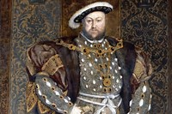](http://www.bing.com/images/search?view=detailV2&ccid=PAMzIOsM&id=5BF69E6BE44A598519FE46D16426AF574CB20C2B&thid=OIP.PAMzIOsMTxqdAQ-aDvY6nQEsDH&q=Henry+the+8th&simid=608054993021505131&selectedIndex=18&adlt=strict)

We will be looking at different structures and investigating simple mechanisms in DT this term. Using our knowledge, we will design and make a simple drawbridge. In Art we will look at the work of Henry Moore.

In Geography,we will look at the local environment and throughout the year we will observe how the landscape changes.

We will be learning about different materials and their properties in our Science work. We will investigate how materials can be changed and how they can be used for different purposes.

If the children have any information they would like to share with the class for this topic please can they bring it into school in a named folder or bag. **We would also love to display in school any castles that have been made by the children.**

