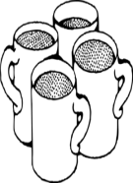
The PTFA are holding a ......

Father’s day
Grandpa, Grandad, Uncle, Brother.......

Crafting session for the special chap in your child’s life.

The PTFA are setting up a special crafting work shop for your child to make a special personalised gift. If you would like your child to take part then please complete the form below and return to the school office along with cash or cheque (made payable to Ursula Taylor PTFA) for £4.00 per gift in an envelope. Many thanks.
All orders much be returned by Friday 27th May.
......................................................................................................
I would like ..................................(child’s name) class.....................................
to make a gift for.................................................(please let us know who the lucky chap is, more than one gift can be made).
I have enclosed cash/cheque for the sum of £................

